**HOME ASSIGNMENT 1**

**Creating a react app:**  
  
1. Creation command:

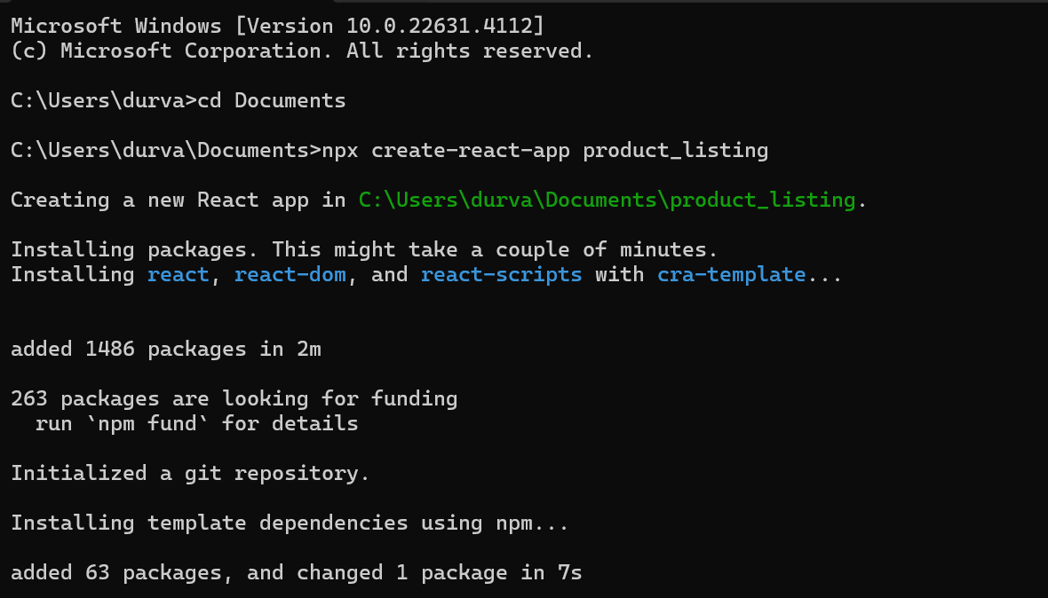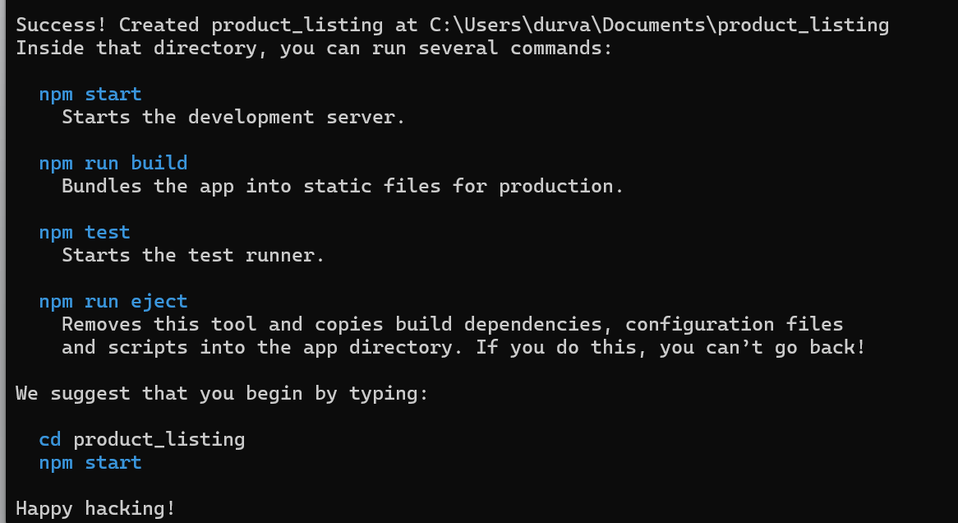**DIRECTORY STRUCTURE:**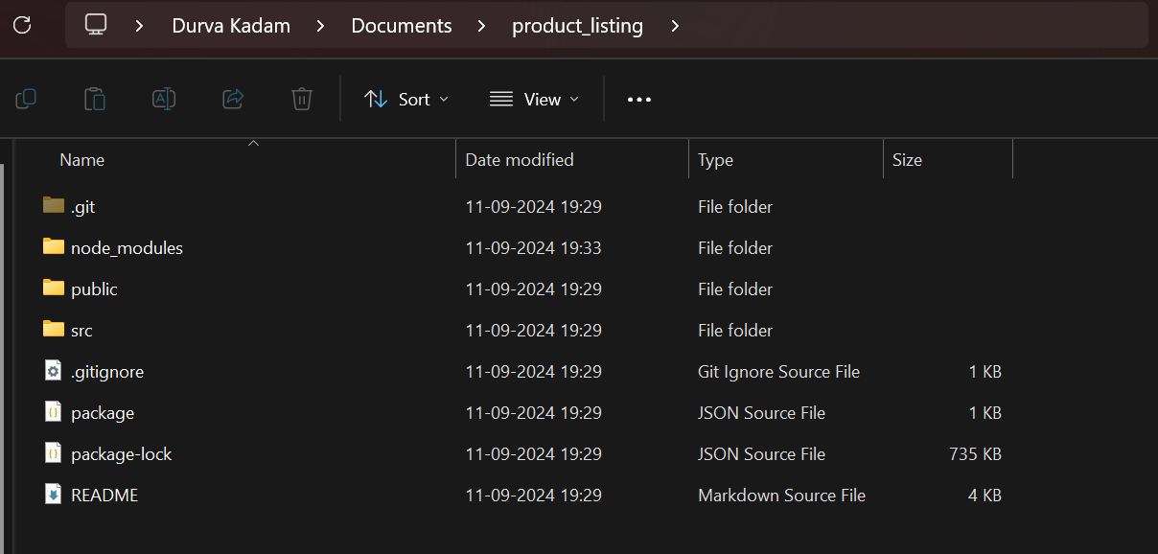

**2. Installation of router:**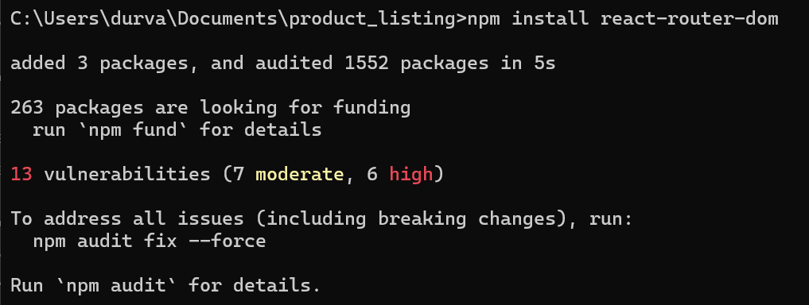

**3. Start the server:**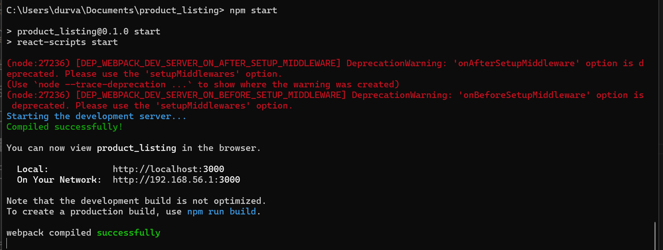

**CODE:  
  
1. LandingPage.js  
  
import React from 'react';**

**import { Link } from 'react-router-dom';**

**import './LandingPage.css'; // Import the CSS file**

**function LandingPage() {**

**return (**

**<div className="landing-container">**

**{/* Existing content */}**

**<h1>Welcome to Our Store</h1>**

**<p>Explore the best collection of designer t-shirts.</p>**

**<Link to="/products">**

**<button className="landing-button">View Products</button>**

**</Link>**

**<br /><br />**

**{/* Display your details */}**

**<div className="student-details">**

**<p><strong>Name:</strong> Durva Kadam</p>**

**<p><strong>Roll No:</strong> 47</p>**

**<p><strong>Subject:</strong> INTERNET PROGRAMMING</p>**

**<p><strong>Date of Submission:</strong> 11/09/2024</p>**

**</div>**

**</div>**

**);**

**}**

**export default LandingPage;**

**2. ProductListingPage.js**  
  
import React from 'react';

import { Link } from 'react-router-dom';

// Import images from the images folder

import tshirt1 from '../images/tshirt1.png';

import tshirt2 from '../images/tshirt2.png';

import tshirt4 from '../images/tshirt4.png';

import './ProductListingPage.css'; // Import the CSS file

function ProductListingPage() {

const products = [

{

id: 1,

name: 'Orange Tie-Dye Tshirt',

price: 'Rs.599',

size: ['S', 'M', 'L', 'XL'],

image: tshirt1,

link: '/product/1'

},

{

id: 2,

name: 'Basic Pink Sweatshirt',

price: 'Rs.699',

size: ['S', 'M', 'L', 'XL'],

image: tshirt2,

link: '/product/2'

},

{

id: 3,

name: 'White Tshirt',

price: 'Rs.799',

size: ['S', 'M', 'L', 'XL'],

image: tshirt4,

link: '/product/3'

}

];

return (

<div className="page-container">

<h1 className="page-heading">

Shop from Our Page

</h1>

<div className="product-container">

{products.map((product, index) => (

<div

key={product.id}

className={`product-box ${index === 1 ? 'center-box' : ''}`}

>

<Link to={product.link}>

<img

src={product.image}

alt={product.name}

/>

</Link>

<h3>{product.name}</h3>

<p>{product.price}</p>

<p>Sizes: {product.size.join(', ')}</p>

<button className="add-to-cart-button">

Add to Cart

</button>

</div>

))}

</div>

</div>

);

}

export default ProductListingPage;

**REACT INTERFACE:**

**LANDING PAGE:**  
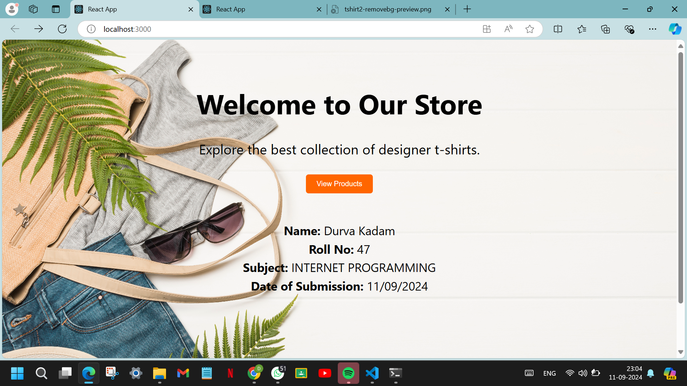

**PRODUCT PAGE:**